|  |
| --- |
| **Objectives:**   * Practice and understanding on basic c++ programs * Control Structure(repetition) * While loop statement * Do-while loop statement * Counter control loop variable * Sentinel controlled loop * Flag controlled loop * Nested Loop |

# Problem: 1 | Nested Loop

Write a program display same output given below

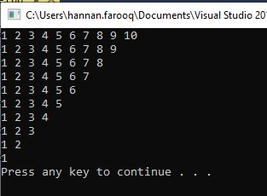

# Problem: 2 | Nested Loop, Triangle variation 1

Make the following triangle with asterisk. Also, the size of the triangle will be defined by user For Example

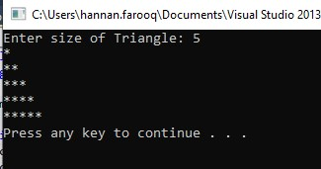

# Problem: 3 | Nested Loop, Triangle variation 2

Make the following triangle with asterisk. Also, the size of the triangle will be defined by user For Example

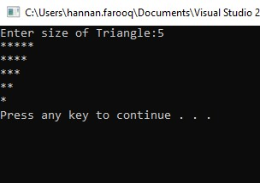

# Problem: 4 | Nested Loop, Triangle variation 3

Make the following triangle with asterisk. Also, the size of the triangle will be defined by user For Example

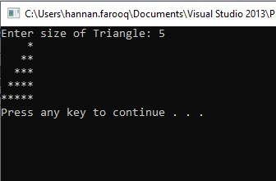

# Problem: 5 | Nested Loop, Triangle variation 3

Make the following triangle with asterisk. Also, the size of the triangle will be defined by user For Example

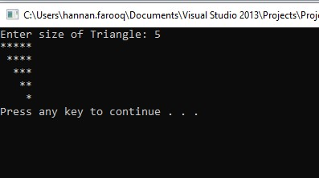

# Problem: 6 | Switch Case, Nested Loop, Triangle Variation

Make a menu driven program that asks user for four triangle variations (P2, P3, P4 and P5) designed in previous problems and let the user switch between the options given by user.

# Problem: 7 | Nested Loop, Pyramid

Make the following pyramid.

*

***

*****

*******

Also make inverted pyramid.

# Problem: 8 |

(Diamond of Asterisks) Write a program that prints the following diamond shape. You may

use output statements that print a single asterisk (*), a single blank or a single newline. Maximize your use of repetition (with nested for statements) and minimize the number of output statements.

Note: The size of diamond should be user defined.

*

***

*****

*******

*****

***

*

# Problem: 9 |

Write a C++ program using while loop that will print the pattern as shown below 1

2= =1

3= =2= =1

4= =3= =2= =1

5= =4= =3= =2= =1

6= =5= =4= =3= =2= =1

7= =6= =5= =4= =3= =2= =1

8= =7= =6= =5= =4= =3= =2= =1

9= =8= =7= =6= =5= =4= =3= =2= =1